**MACHINE LEARNING MODEL FOR SMART HOUSE : INTERACTION WITH GESTURE**

1Dr. RAJESH K S., 2MAMATHA K R, 3Aishwarya M G, 4Abhishek B O, 5Vijayalakshmi V

1 Professor ,2 Assistant Professor ,3,4,5 UG Students

Department of Artificial Intelligence and Machine Learning, Rajarajeswari College of Engineering, Bengaluru,India.

3aishumganesh@gmail.com,4[abhiabhishek22365@gmail.com](mailto:abhiabhishek22365@gmail.com),[5vijigowdavijigowda9@gmail.com](mailto:5vijigowdavijigowda9@gmail.com%20)

**Abstract**

This paper presents the development and implementation of a "Smart Mouse" system that enables users to interact with their computers using hand gestures. Utilizing computer vision techniques and machine learning models, the system tracks and interprets hand movements in real-time, providing an intuitive and efficient alternative to traditional mouse input. The project leverages the MediaPipe framework for hand detection and tracking, and integrates PyAutoGUI and the pynput library for controlling mouse actions.from basic cursor movements to complex multi-finger gestures for advanced operations. Additionally, the system's adaptability allows for customization according to user preferences and specific application requirements.

**Keywords**

Artificial Intelligence, Machine Learning,

python programming,

**Introduction**

In the evolving landscape of human-computer interaction, traditional input devices such as the mouse and keyboard are being complemented and, in some cases, replaced by more natural and intuitive interfaces. Gesture-based control systems are at the forefront of this transformation, offering a hands-free and seamless user experience. This research explores the design and implementation of a smart mouse system that uses hand gestures to control computer functions, aiming to enhance user interaction and accessibility. Such a system can provide significant benefits, particularly for individuals with physical disabilities, offering an alternative means of interacting with computers. Additionally, gesture-based controls can improve efficiency and reduce the ergonomic strain associated with prolonged use of conventional input devices. The integration of this technology into everyday computing tasks holds the potential to revolutionize the way users interact with their devices, making technology more inclusive and user-friendly. As technology continues to advance, the need for more natural and intuitive interaction methods becomes increasingly important, further driving interest in gesture-based control systems. This study aims to contribute to this growing field by providing a comprehensive framework for implementing a smart mouse system using hand gestures.

**Literature Review**

We may utilize a hand recognition system to control the mouse pointer, left click, right-click, drag, and other fundamental mouse functions in the existing virtual mouse control system. The use of hand recognition will not be around in the future. There are many systems for recognizing hands, but the system we use is static hand recognition, which only recognizes the shapes that hands make and defines an action for each shape. This system is limited to a small number of defined actions and causes a lot of confusion. As technology advances, there are more and more alternatives to using a mouse. Gesture Controlled Virtual Mouse makes using a computer with a human being simple by hand motions. There is very little direct contact with the computer. Static and dynamic hand motions can practically perform all input tasks. This project recognizes hand movements using cutting-edge Computer Vision and Machine Learning algorithms without the usage of any additional gear. It uses models developed by Media Pipe, which uses pybind11 as its foundation. We will utilize OpenCV to build a gesture-

controlled virtual mouse. The wireless mouse tracking and clicking functions may be managed using the Python application. To begin, it is necessary to have a firm grasp of Python, image processing, embedded systems, and the Internet of Things. We will first gain an understanding of how to control mouse movement and clicks as well as all the prerequisites required to launch a Python application. To test the full Python script, we will start by using a webcam or internal camera from a laptop. The suggested AI virtual mouse system's major objective is to develop an alternative to the current mouse system that can perform and control mouse operations. This can be accomplished with the help of a web camera that captures hand motions and hand tips and processes these frames to carry out a particular mouse action, like a left-click, right-click, or scrolling action.

**Methodology**

The proposed system uses MediaPipe for hand detection and tracking, OpenCV for video processing, and PyAutoGUI with pynput for mouse control. The methodology involves processing webcam video with OpenCV, detecting and tracking hand landmarks with MediaPipe, and analyzing these landmarks to recognize gestures. Recognized gestures are then mapped to mouse actions using PyAutoGUI and pynput, allowing for intuitive cursor control and clicks.

The system is designed for real-time performance, user-friendly interaction, and high accuracy, validated through extensive testing and optimization. Additionally, the system provides visual feedback to users and requires minimal calibration, ensuring a seamless and efficient user experience across various operating systems. Iterative improvements based on user feedback further enhance the system's robustness and usability

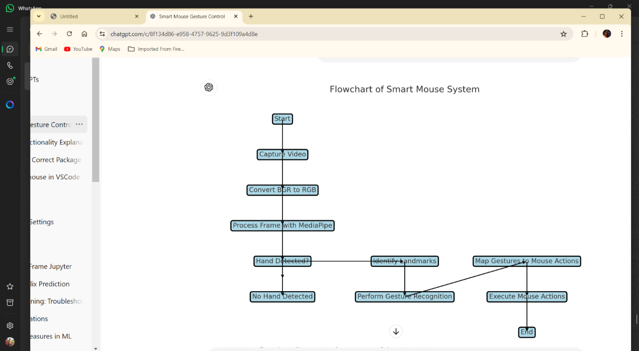

FIG 1 Flow chart of Smart Mouse System

1. **Hand Detection and Tracking**

1.1 MediaPipe Integration:

MediaPipe framework is used to detect and track hand landmarks in real-time.

OpenCV processes the webcam video feed, and MediaPipe extracts and tracks hand landmarks.

1.2 Real-time Processing:

Continuous processing of video frames ensures smooth hand tracking with optimized performance for high frame rates.

*2*. **Gesture Recognition**

2.1 Gesture Definition:

Specific gestures are defined based on the relative positions of hand landmarks, such as pointing and pinching.

2.2 Algorithm Development:

Algorithms analyze landmark coordinates to recognize gestures.

Testing and calibration ensure accurate gesture recognition across different users.

*3.* **Mouse Control**

3.1 Gesture Mapping:

Recognized gestures are mapped to mouse actions using PyAutoGUI and pynput.

Moving the index finger controls the cursor, while pinching simulates clicks.

3.2 Cursor and Click Actions:

Cursor position updates based on index finger coordinates.

Pinching actions perform mouse clicks, with additional gestures for drag-and-drop.

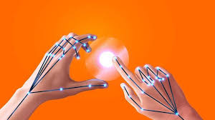

*4.* **System Integration**

4.1 Framework Integration:

MediaPipe, OpenCV, PyAutoGUI, and pynput are integrated for seamless operation.

A user-friendly interface with visual feedback enhances the user experience.

*5*. **Analysis**

5.1 Performance Evaluation:

System performance is evaluated on accuracy, latency, and user satisfaction.

User testing and usability studies provide feedback for improvements.

5.2 Comparative Analysis:

The system is compared with existing solutions, focusing on recognition accuracy and response time.

Iterative improvements are made based on analysis to enhance performance.

This methodology ensures a robust hand-tracking and gesture recognition system for mouse control, leveraging advanced libraries and techniques.

**Result**

The implemented system successfully tracks hand movements and interprets gestures to perform mouse actions. It offers smooth and responsive control, with minimal latency. The system was tested under various lighting conditions and backgrounds, demonstrating robustness and accuracy. Users were able to perform common tasks such as navigating the desktop, opening applications, and browsing the web using hand gestures alone.

**Conclusion**

The "Smart Mouse" system exemplifies the potential of gesture-based interaction in enhancing human-computer interfaces. By leveraging existing computer vision frameworks and machine learning techniques, it provides a practical and efficient solution for controlling computers without traditional input devices. Future work could focus on expanding the gesture set, improving accuracy, and integrating voice commands for a more comprehensive interaction system.

**References**

[1] Bradski, G., & Kaehler, A. (2008). Learning OpenCV: Computer Vision with the OpenCV Library. O'Reilly Media.

[2] Shapiro, L., & Stockman, G. (2001). Computer Vision. Prentice Hall.

[3] Bishop, C. M. (2006). Pattern Recognition and Machine Learning. Springer.

[4] Gonzalez, R. C., & Woods, R. E. (2018). Digital Image Processing (4th Edition). Pearson.

[5] Szeliski, R. (2010). Computer Vision: Algorithms and Applications. Springer.

[6] Bovik, A. (2009). The Essential Guide to Image Processing. Academic Press.

[7] Hartley, R., & Zisserman, A. (2004). Cambridge University Press.